QUESTION 3

Bar Chart showing the amount of students in each age.
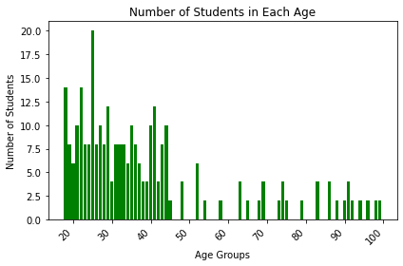
The tallest bar in the chart indicates the age group with the highest number of students, suggests that it is the dominant age group within the student population.
We can see that students between the ages of 20 and 30 are the students that mostly wrote the examinations.
As we progress past the approximately the age of 47, we can see that the number of students are significantly reduced. The blank lines as the age groups progress, proves that most ages do not write the exams.
Ages over 45 are less likely to write exams.

SOURCE CODE FOR BAR CHART
#import matplotlib for plotting
import matplotlib.pyplot as plt

# converted the dictionary to a DataFrame because it is more efficient for matplotlib
age_df = pd.DataFrame(list(age_frequency.items()), columns=['AgeGroup', 'Frequency'])

# Create a bar chart
plt.bar(age_df['AgeGroup'], age_df['Frequency'], color='green')
plt.xlabel('Age Groups')
plt.ylabel('Number of Students')
plt.title('Number of Students in Each Age')
plt.xticks(rotation=45, ha='right') #i rotated the x axis values so that they don't overlap each other
plt.tight_layout()
# Show the plot
plt.show()

Line Plot showing the correlation between time spent on exams and the mark that they got.
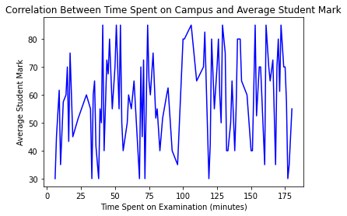
The correlation between time spent on campus and average student mark fluctuates, going up and down.
But we can see that students that spent between 0 and 25 minutes got the lowest marks.
SOURCE CODE FOR LINE PLOT
# Aggregate data by taking the average mark for each 'ExamTime'
average_marks = ds.groupby('ExamTime')['Mark'].mean().reset_index()
# Line graph
plt.plot(average_marks['ExamTime'], average_marks['Mark'], linestyle='-', marker='', color='blue')

plt.xlabel('Time Spent on Campus')
plt.ylabel('Average Student Mark')
plt.title('Correlation Between Time Spent on Campus and Average Student Mark')
plt.show()
Scatterplot for Student Mark and the time spent in the exam room
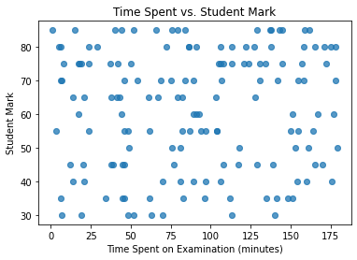
From this scatterplot we can see there is barely any correlation between time spent in the exam room and the Student Mark. (Except for the 0 and 25 minutes ratio), where they got some of the lower marks.
Students that spent much longer time in the exam also got low marks, maybe because not knowing what to do.
SOURCE CODE
#scatterplot for time spent in exam vs the student marks
#added alpha so that i can fine-tune some of the plots
plt.scatter(ds['ExamTime'], ds['Mark'], alpha=0.5)

plt.xlabel('Time Spent on Examination (minutes)')
plt.ylabel('Student Mark')
plt.title('Time Spent vs. Student Mark')
plt.show()

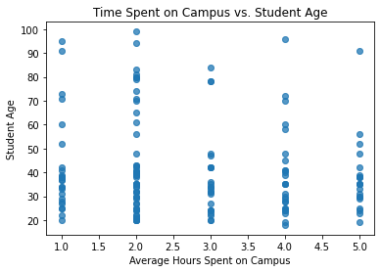
Scatter plot for time spent on campus vs the Student Age
My scatterplots appear as a vertical line, which may indicate that the relationship between avg hours spent on campus and student age is discrete in nature.
Many students that spent 2 or 1 hour(s) are in the age range of 20-40.
SOURCE CODE
# Scatter plot for time spent on campus vs the Student Age
plt.scatter(ds['StudyHours'], ds['AgeGroup'], alpha=0.5)

plt.xlabel('Average Hours Spent on Campus')
plt.ylabel('Student Age')
plt.title('Time Spent on Campus vs. Student Age')
plt.show()

QUESTION 4.6

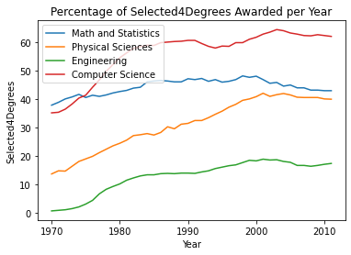
Multiple line plot showing the degrees women got in certain STEM fields.

From the plots I can deduce that:
- During the 1970s decade we can see that Engineering started to gain popularity and the same can go in 80s well. Interest in that major gained less popularity in the 90s but still rose. Interest/popularity in the Engineering Major reduced in the 2000.
- For Physical Sciences, It constanty gained popularity up to the year 200, where interest is lost again.
- For Mathematics and Stats, it constantly rose and fell all throughout 1970 and 2010.
- We can see that Maths&Stats and Computer Science crossed over in the years between 1970 and 1980. Meaning same amount got degrees in both fields.
- Computer Science is the opposite of Mathematics and Stats, where it gained a lot of popularity between 1970 and 1980, after 1990 there was a decline but rose after 2000 then declined again.

